PERSISTENT STORAGE WITH DOCKER VOLUMES

What is Docker Volume
- A Docker volume is used to store data permanently outside the container’s writable layer.
- This means that even if the container stops, is removed, or recreated, the data stored in the volume remains safe.
- we can allocate a single volume to multiple containers to share the data
- we cannot allocate or create a volume from the existing container only we can allocate while creating.
- volume will not be included when you update an image.
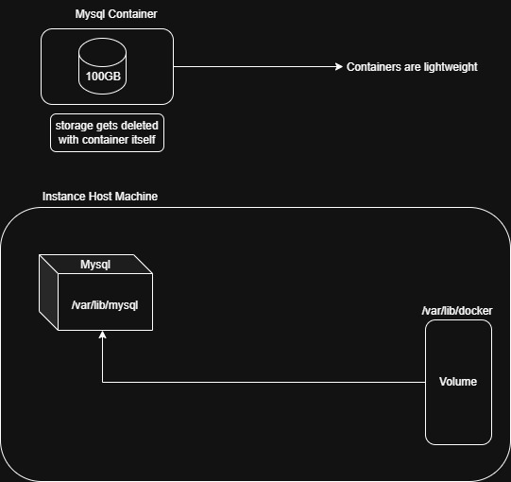

TYPES OF VOLUMES
- Named volume
- Bind mounts volume
- Anonymous Volume

NAMED VOLUMES
A volume which is directly managed by Docker, stored in Docker’s internal storage (usually /var/lib/docker/volumes/).

COMMANDS
Create a instance & attach a volume
- docker volume create my_volume
- ls /var/lib/docker/volume/
- docker run -d -p 8081:80 –name nginx -v my_volume:/usr/share/nginx/html/ nginx
- <public_ip:8081>
- ls /var/lib/docker/volumes/

Delete a instance & reattach this volume to another instance
- docker run -d -p 81:80 –name httpd -v my_volume:/usr/local/apache2/htdocs/ httpd
- <public_ip:81>
- cd /var/lib/docker/volumes/
- ls

BIND MOUNTS
Maps a specific file or directory from the host machine into the container.
- Directly uses host filesystem
- Full control over file location
- Changes reflect immediately on both sides
- Less portable (depends on host path)

PRACTICAL
- mkdir /root/mywebsite
- cd mywebsite
- vim index.html
<h1> Welcome from Host Machine </h1>
- docker run -d -p 8081:80 --name nginx_container -v /root/mywebsite:/usr/share/nginx/html nginx
- <public_ip:8081>
- cd mywebsite
- Vim index.html
<h1> Welcome to Bind Mount </h1>
- <public_ip:8081>

ANONYMOUS VOLUME
- Data is shared between containers.
- If one container changes files, the other container can see them.
- Useful for backup containers or shared storage.
- --volumes-from copies volume mounting information from another container.
CREATE CONTAINER-1
1.docker run -it --name container1 -v /volume ubuntu /bin/bash
- cd /volume
- touch file{1..10}
- exit
SHARE VOLUME WITH CONTAINER-2
1.docker run -it --name container2 --volumes-from container1 ubuntu /bin/bash
- cd /volume
- ls

Container2 is using the same volume created by Container1.

HOW TO DELETE VOLUMES
- docker volume delete my_volume

HOW TO CREATE MYSQL CONTAINER
- docker volume create mysql-data
- docker volume ls
- docker run -d --name mysql-container -p 3306:3306 -e MYSQL_ROOT_PASSWORD=root123 -v mysql-data:/var/lib/mysql mysql:latest
- docker exec -it mysql-container /bin/bash
mysql -u root -h localhost -proot123
- ls /var/lib/docker/volumes/mysql-data/
{You get all the files of mysql-container}

Note:
- /var/lib/mysql is the default location where MySQL stores databases.

